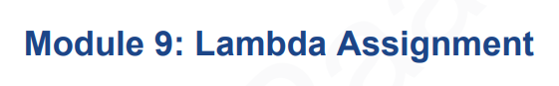

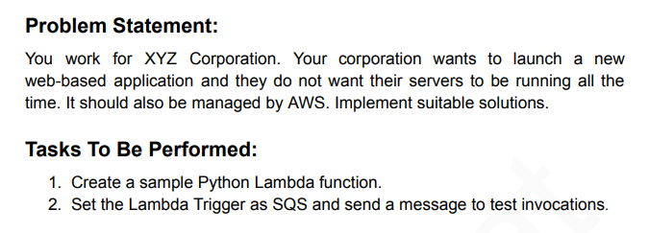

1. Go to Lambda Service and Create Function

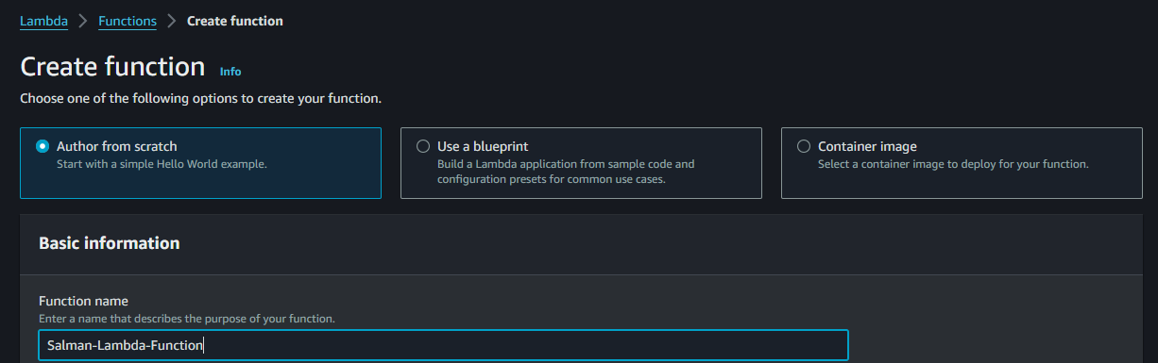

1. Select Runtime Version and Architecture

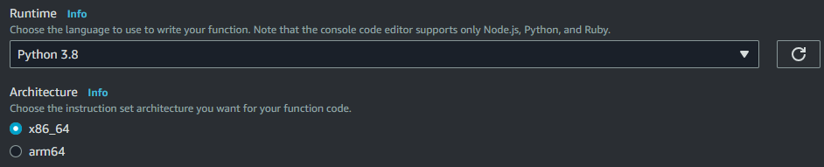

1. Before Selecting Role So we create a Role for Lambda and GO to IAM > Services Lambda

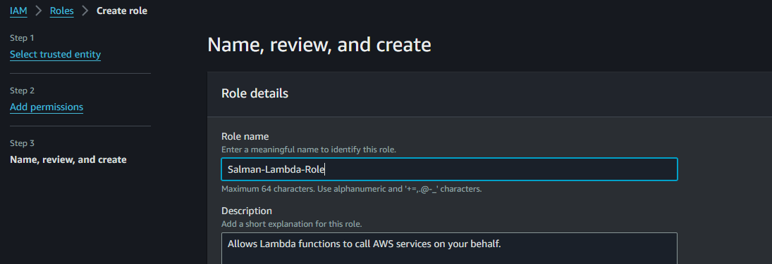

1. Example I will Allow Permissions S3 and Cloudwatch Full Access and Hit the Button Created

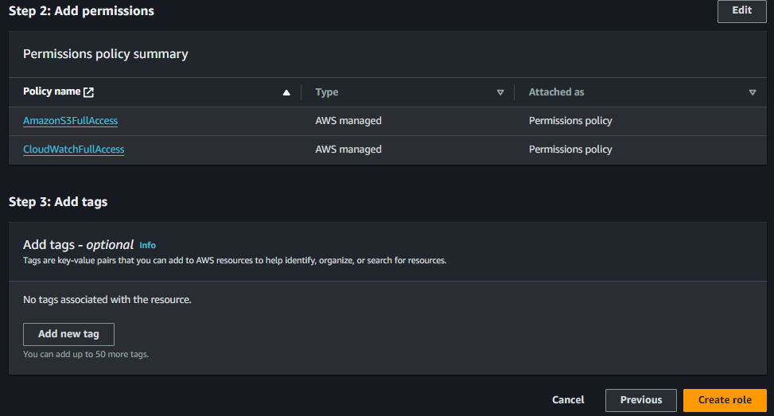

1. Role Created Successfully

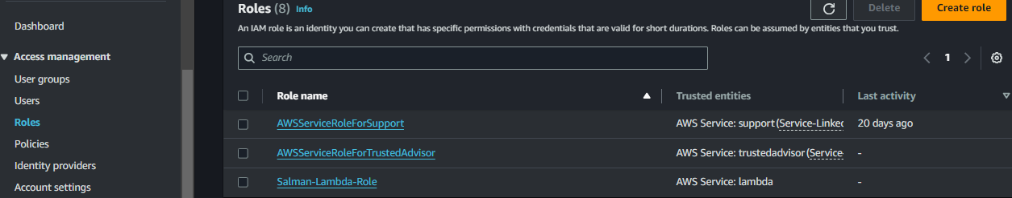

1. And Now Go to Lambda Function Now Select Existing Role which we Created

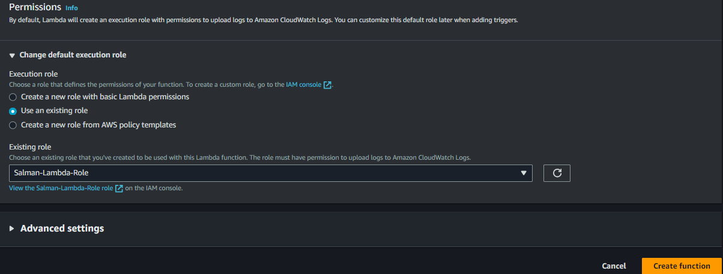

1. Deploy the Python Program and Test it

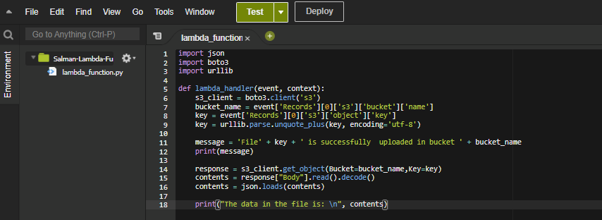

1. And Need to be Add the Trigger(We Here Select S3 as a Trigger) and Select Here Your S3 Bucket and before that need to create a Bucket which I already created

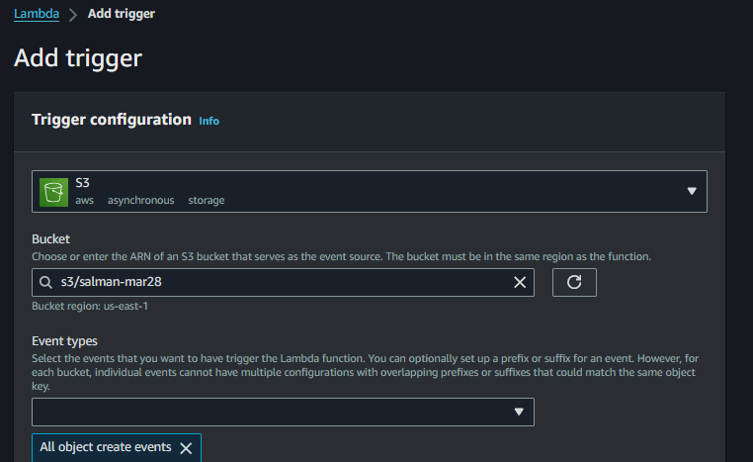

1. Acknowledge and Add

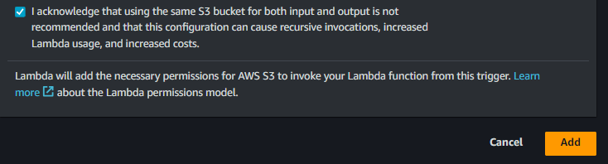

1. Go to S3 selected Bucket Make sure u have to create a Bucket which u selected region for Lambda and Upload a Json File which we written in the code Allow Messages to S3 and the Destination is SQS

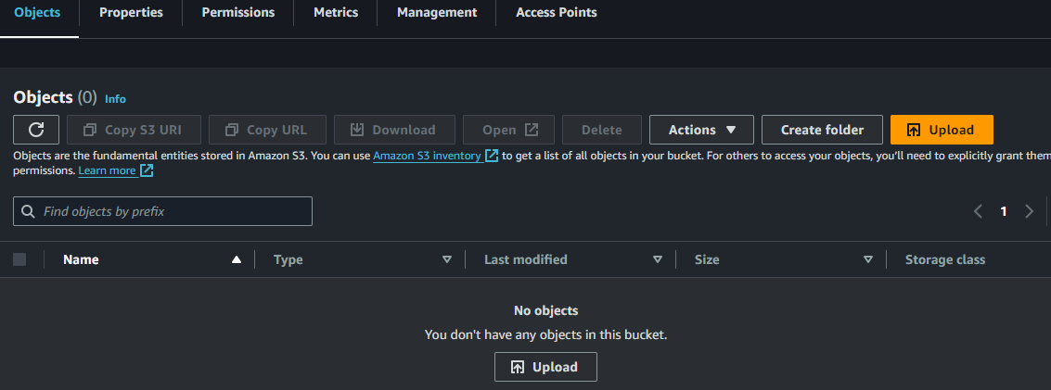

1. Uploaded Successfully

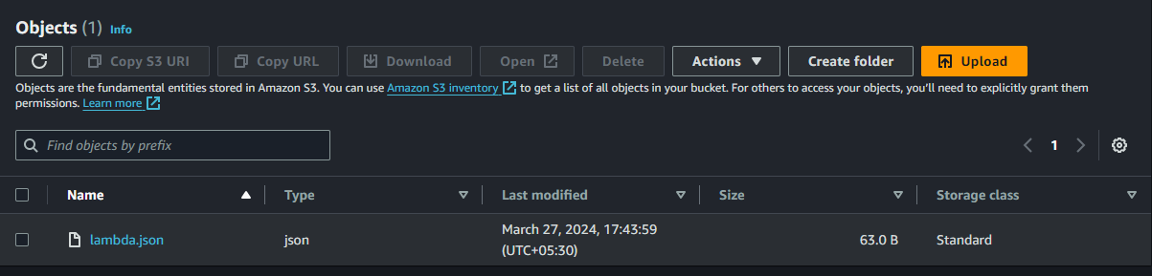

1. In Lambda we find a Monitor Option Click On it and it will open different tab and go Cloudwatch Dashboard and We Find Logs Groups

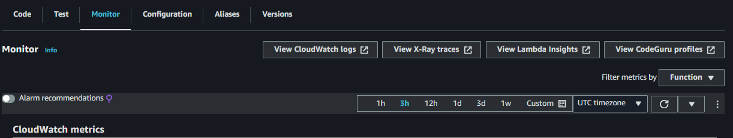

1. We Can see Log Stream

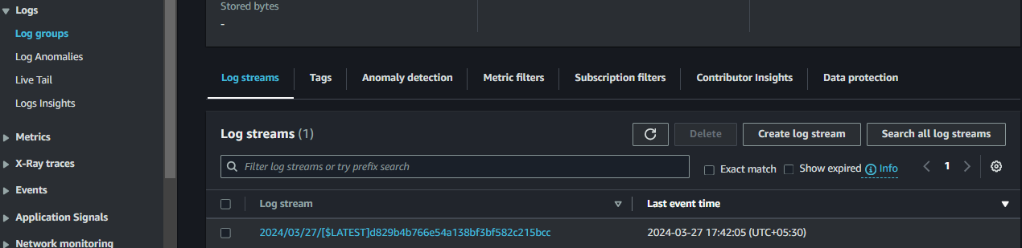

1. The messages Passes Successfully in cloudwatch and we can see in Logs which running and also we Allowed Permissions to Cloudwatch for Lambda

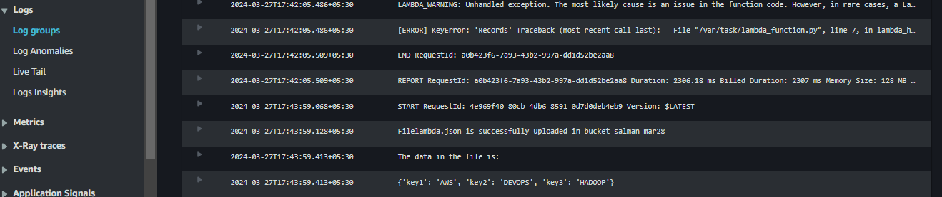

1. So Now our Destination is Pass the Message to SQS so Need to Attach SQS Permissions to Lambda Role

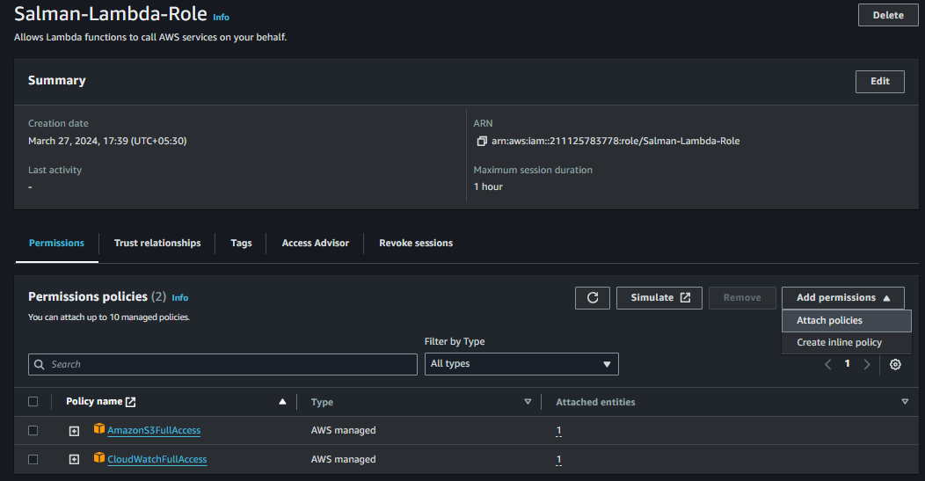

1. See We Attached SQS Full Access Permission

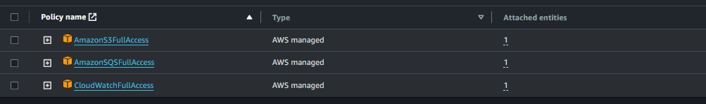

1. Go To SQS Create a Queue

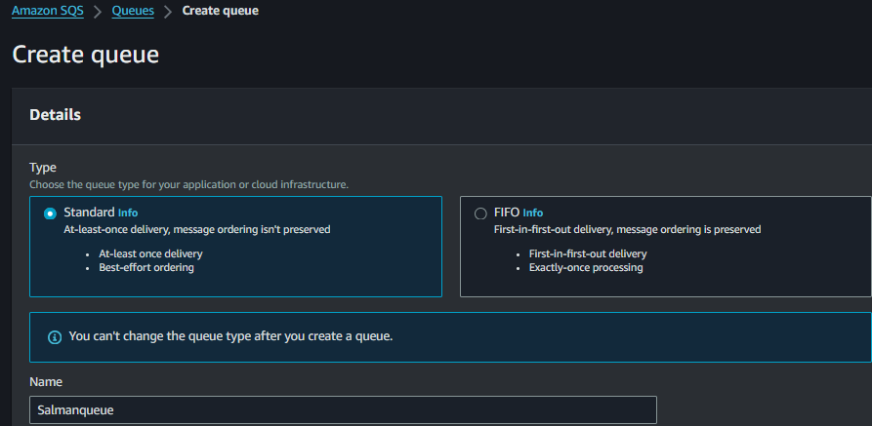

1. See Currently the Poll Messages is Zero

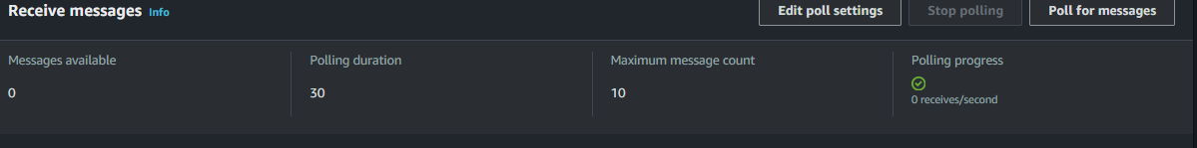

1. Go to Lambda Function Click Destination and Select Destination Type and Create it

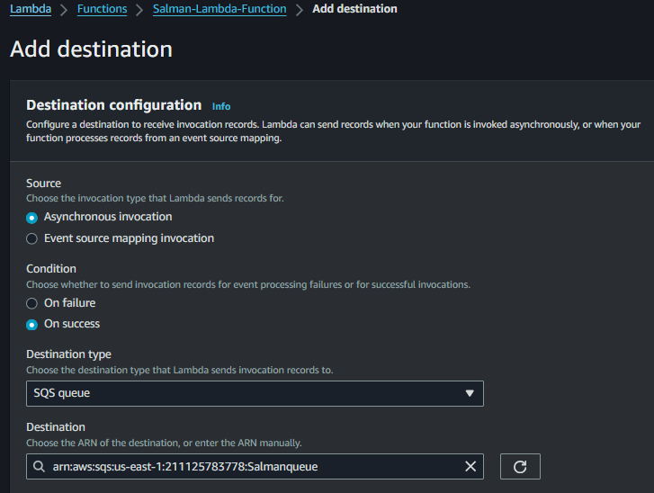

1. Destination Also Added.

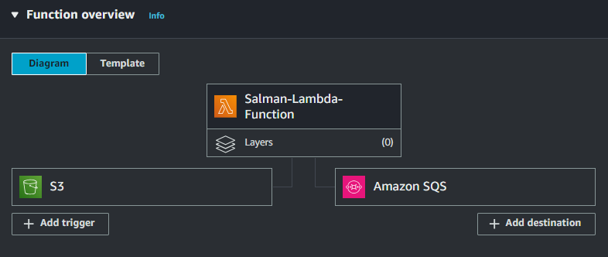

1. Once Again Re-upload the Json Doc to Trigger from s3 and Passes the Message to SQS

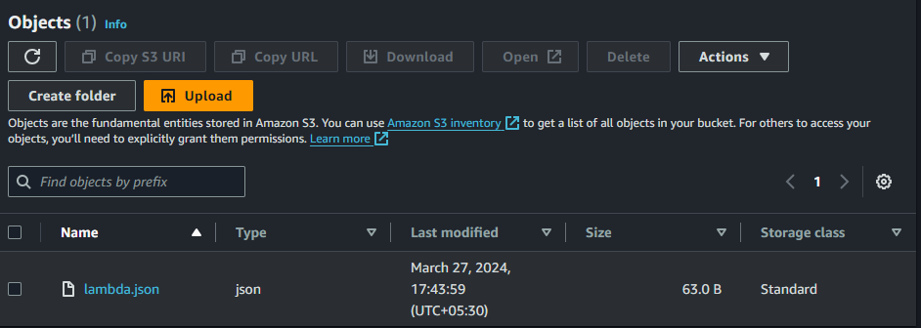

1. Reupload Successfully

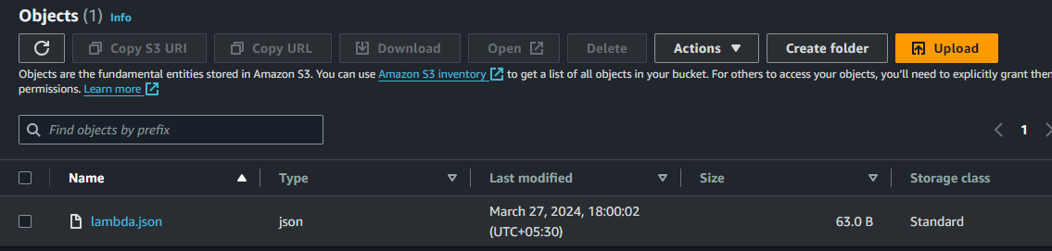

1. Now to SQS Click Poll for Messages and it shows one Message which is triggered from S3

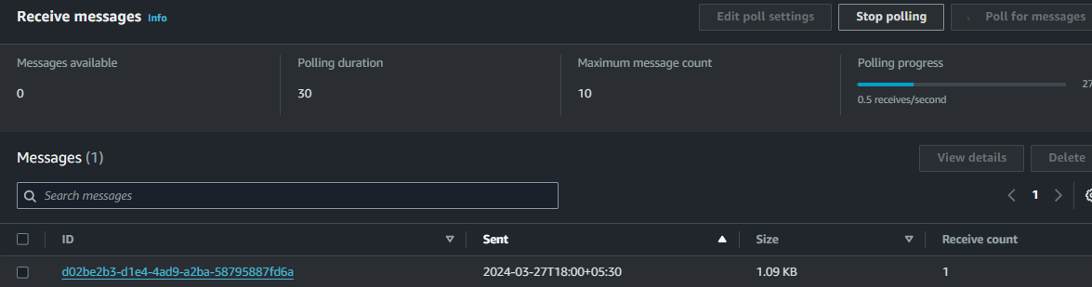

1. Message Received.

Message Triggered from S3 and Particularly we written the code for Allowing only Json File and It Passes the Message to Destination and We Add Permissions to Cloudwatch So Logs Also Generated

